FINAL EXAMINATION
TIME ALLOWED: 90’
Subject: Linear Algebra. No books allowed.

1/ Calculate 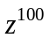, given that 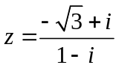.

2/ Find the matrix , such that 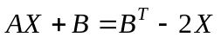, where 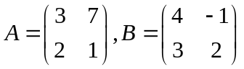.

3/ Find all real value(s) m such that 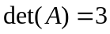, given that 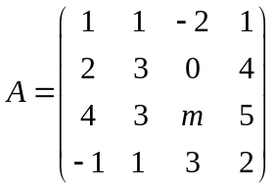.

4/ Let 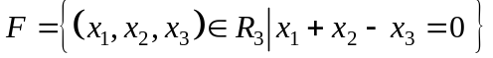 and
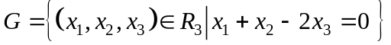 be two subspaces of a vector space 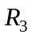.
Find one basic and a dimension of the intersection 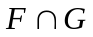.

5/ Given the inner product in as follow:
and the subspace 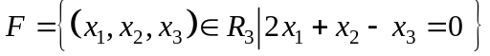.
Find one basic and a dimension of the orthogonal compliment 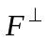.

6/ Let 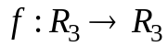 be a linear transformation.
Assume that .
a/ Compute 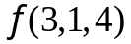.
b/ 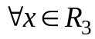, 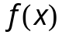.

7/ Diagonalize (if possible) the matrix 

  

